***X-Axis [3.0]***

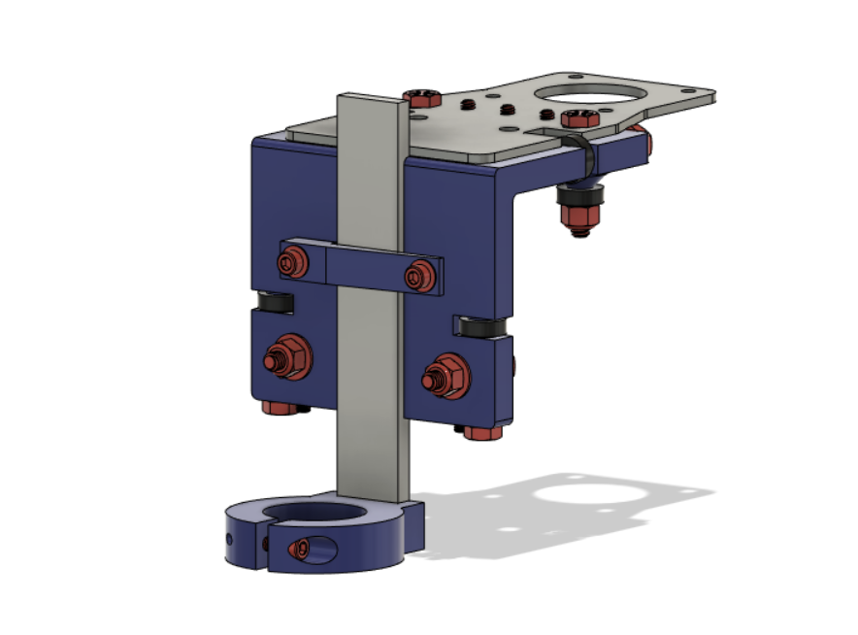

***Bearings [3.1]***

**Parts Needed**

**1x X-Axis (3D Printed)**

**2x Standoffs (3D Printed)**

**10x R4ZZ Bearing Washers (3D Printed)**

**2x 1/4” - 1.5” Bolts**

**4x 1/4” - 2” Bolts**

**4x 1/4” - 3/4” Set Screw**

**2x 1/4” Washers**

**2x 1/4” Lock Nuts**

**6x R4ZZ Bearings**

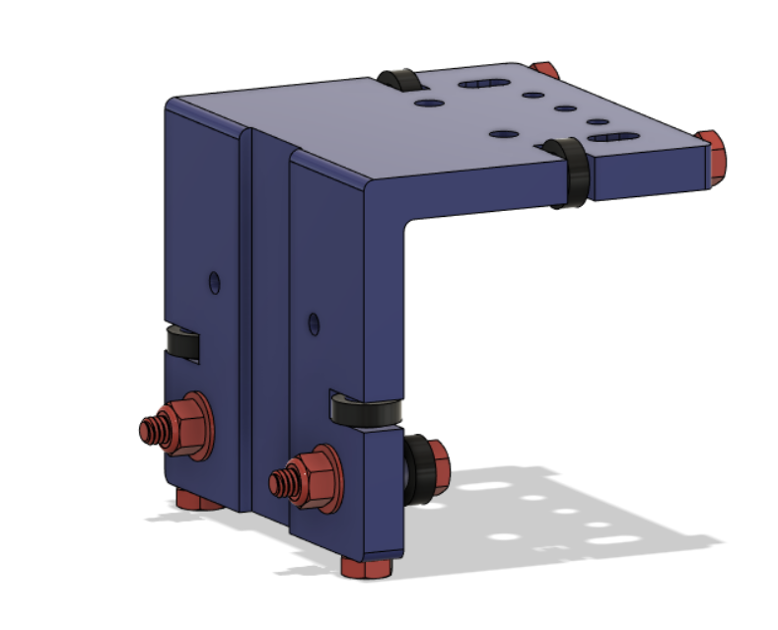

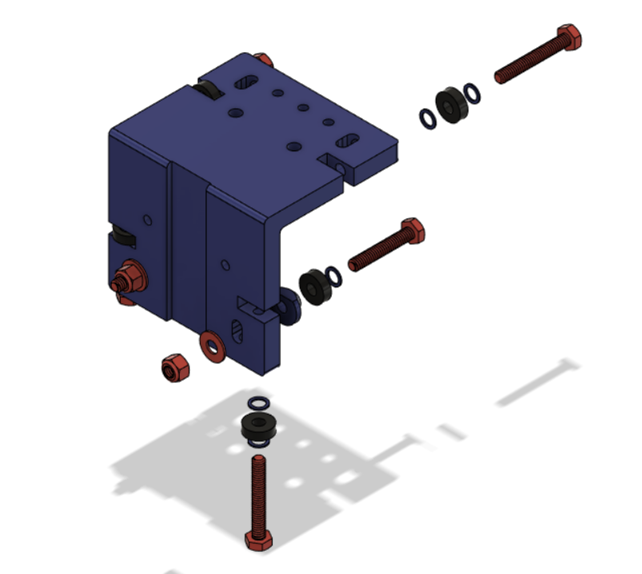

Use the longer bolts to thread into the ends of the X-Axis part. Short bolts are used in the adjustment slots.

**PRO TIP:** Use a 2.5” bolt instead of a 2” bolt and cut off the extra 1/2” to provide a smooth surface for the inner bearing race to ride on. Also use a 1.75” bolt instead of a 1.5” bolt and cut the extra 1/4” off.

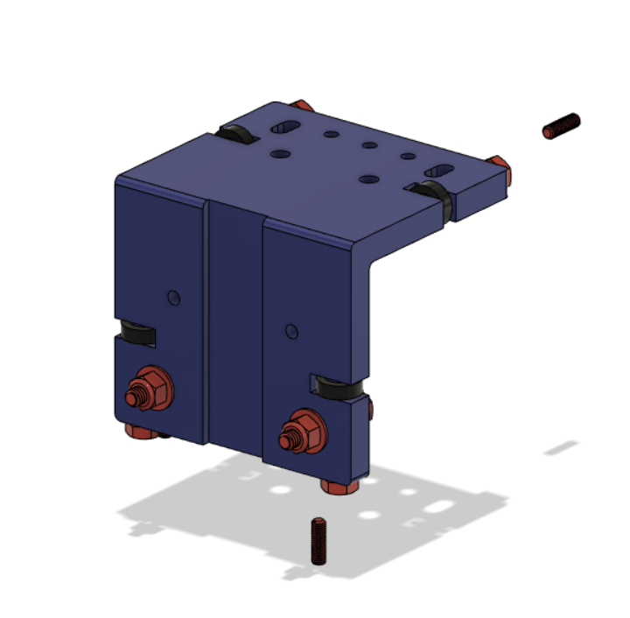

Insert the 4 set screws, these are used to set the plumb of the X-axis

***Motor Plate [3.2]***

**Parts Needed**

**1x X-Axis with Bearings**

**2x Standoffs (3D Printed)**

**2x R4ZZ Bearing Washers**

**1x X-Motor Plate**

**2x 1/4” - 1.5” Bolts**

**2x 1/4” Lock Nuts**

**3x #10-32 - 1/2” Screws**

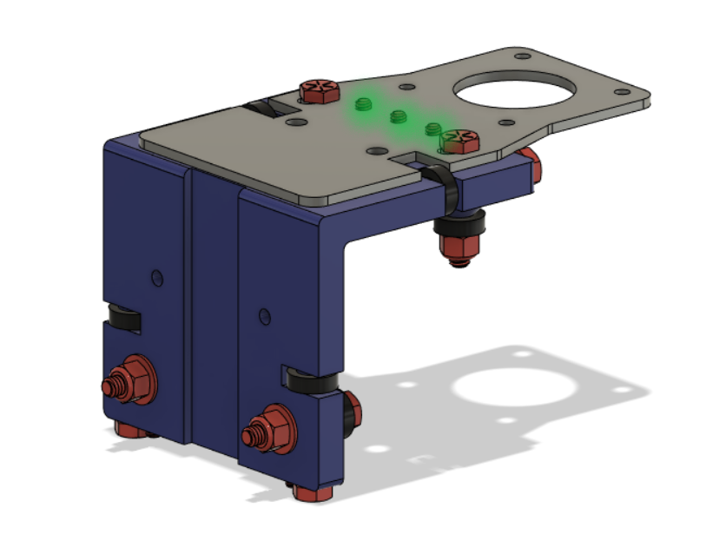

**Pro Tip:** Grind bolts off in the green area so that they are flush to the motor plate if they are not flush already

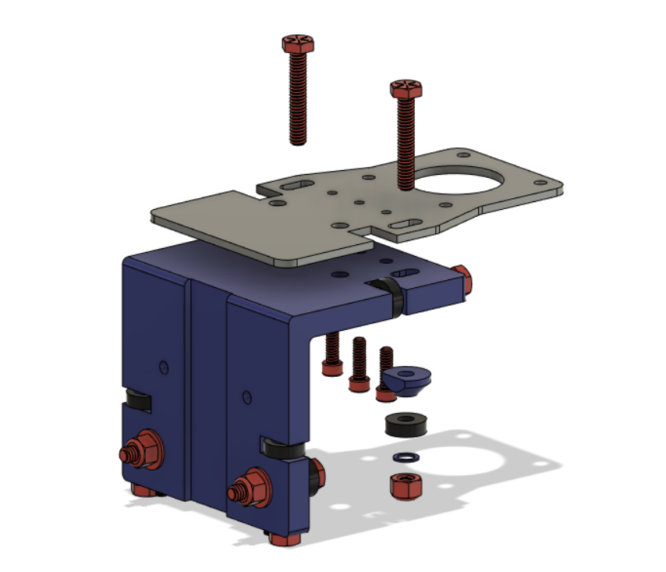

X-axis must be plumb to the bed surface. Process: Adjust the lower adjustable bearings so they are not touching the tube. Slightly tighten 1/4" bolts on upper adjustable bearings. Use a square to measure from bed to aluminum torch bar. Adjust the upper set screws to achieve plumb. Firmly tighten 1/4" bolts. Adjust lower bearings so they just make contact with the tube and check that they spin when moving the assembly. Firmly tighten the lower 1/4" bolts on the adjustable bearings. Check that there is no play or rack on the X-axis bearing assembly.

***Torch Holder [3.3]***

**Parts Needed**

**1x X-Axis with Motor Plate**

**1x Torch Clamp (3D Printed)**

**1x Torch Holder (3D Printed)**

**1x Torch Bar**

**1x #10-32 - 3/4” Screw**

**2x 1/4” - 3/4” Bolt**

**1x 1/4” - 1/2” Bolt**

**2x 1/4” Washer**

